Welcome to Kikhavn
You have arrived in a beautiful and unique landscape in the Northern part of Seeland which is enjoyed by many temporary and permanent residents.
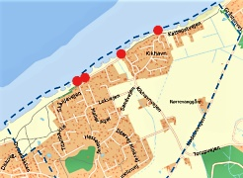

Kikhavn stretches from the slopes at Spodsbjerg to the west and Gråstenvej to the east. Kattegat (the sea) lies to the north and the border to the south is Lille Karlsmindevej. Selve Kikhavn landsby udgør et bevaringsværdigt kulturmiljø og det bakkede kystnære sommerhusområde giver enestående muligheder for store naturoplevelser, udsigt ud over havet og det åbne land.
We hope that you will appreciate this environment as much as us and help preserve the beautiy intact.
We thank you in advance for helping us to maintain the integrity of both the landscape and the village by reading and respecting the following rules and guidelines.

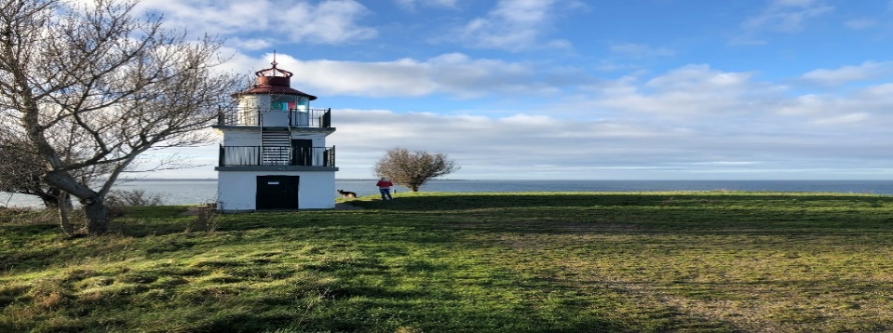

Beach
Please only use the public entries/stairs to the beach (see the red dots on the map on front page). It is not allowed to walk on the dyke. Furthermore, please observe that some of the beaches in the area are privately owned. In practice, this means that it is not allowed to walk or sit on the beach if you are within 50 meters of the houses.
Dogs must be kept on a leash from 1 April to 30 September and it is expected that you clean up after your dog / remove waste after yourself and place it in the trash bins.
Speedboats and jet skis are forbidden.

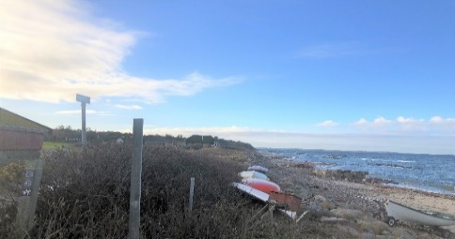
Roads
Parking should be done in such a manner that other vehicles, including emergency vehicles and renovation trucks, are able to pass on the road.
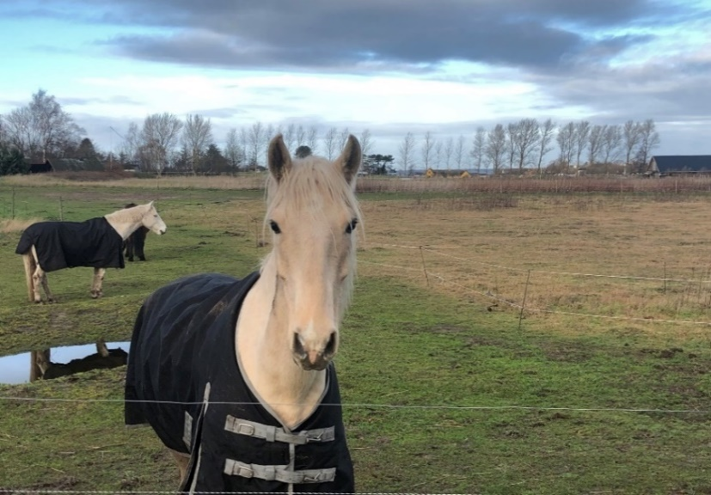
Traffic
Please be advised that the roads are narrow and visibility is often limited. We ask that you do not exceed the speed limit of 20 km/hour, whether by car or bicycle. Please be aware that people, including children walk on the road.
Noise
Because of the hilly landscape, sound resonates. We kindly ask that you show consideration by limiting loud noises, such as music and barking dogs, etc. If you are going to have a party it is a good idea to inform your neighbors in advance.
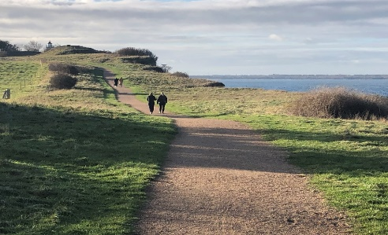
Fireworks
Fireworks are a serious threat to the many thatch roofed houses in the Kikhavn area.
You must obey the legislation for fireworks which state that there must be a minimum distance of 200 meters/400 meters to thatch roofed houses if they are located in the direction of the wind. Remember that there are many thatched houses in the area.
We hope that you will enjoy your stay in Kikhavn and look forward to seeing you again.
Greetings from
Kikhavn Home owners association.

